**POC - Kubernetes Installation, Configuration & Manage**

**Pre-requisite**

On windows, install Oracle Virtual Box and Vagrant latest versions.

Create any folder and clone the project under the folder from below github link.

Link: <https://github.com/harish31/k8springbootdemo.git>

Now go to “k8springbootdemo/K8s POC” folder and run “vagrant up” command without quotes. It will create three virtual machines i.e. one Kubernetes master node and two worker nodes with all the configuration and joining of the nodes to the master with the help of bootstrap shell scripts. We can increase the worker nodes as per our requirement by editing the Vagrantfile.

Once all machines are up and running, run the below commands on master to check if the K8s master is running fine and nodes has been joined to the K8s master.

#kubectl cluster-info



#kubectl get nodes

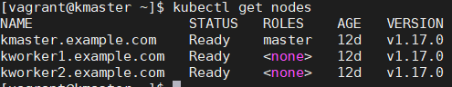

**Kubernetes Dashboard**

Run below commands

#kubectl apply -f https://raw.githubusercontent.com/kubernetes/dashboard/v2.0.0-beta8/aio/deploy/recommended.yaml

To check the dashboard service name run below command

#kubectl -n kubernetes-dashboard get svc



Once we get service name, edit the service config file with the help of below command and change ClusterIP to NodePort and add any random port here to access the dashboard from outside the cluster. In my case I have assigned port 32323.

#kubectl -n kubernetes-dashboard edit service kubernetes-dashboard

Now run again the below command to check the changes has been affected or not.

#kubectl -n kubernetes-dashboard get svc



Now create the service account to access the Kubernetes Dashboard by executing below command and check if the service account has been created or not.

#kubectl create -f sa_cluster_admin.yaml

#kubectl -n kubernetes-dashboard get sa



Below command will give the brief description about the service account. Copy the highlighted token.

#kubectl -n kubernetes-dashboard describe sa kubernetes-dashboard

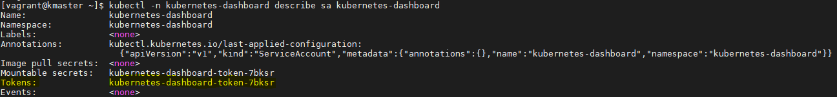

Now run the below command to get the actual login token to access the Kubernetes Dashboard.

#kubectl -n kubernetes-dashboard describe secret kubernetes-dashboard-token-7bksr(paste_token_here)

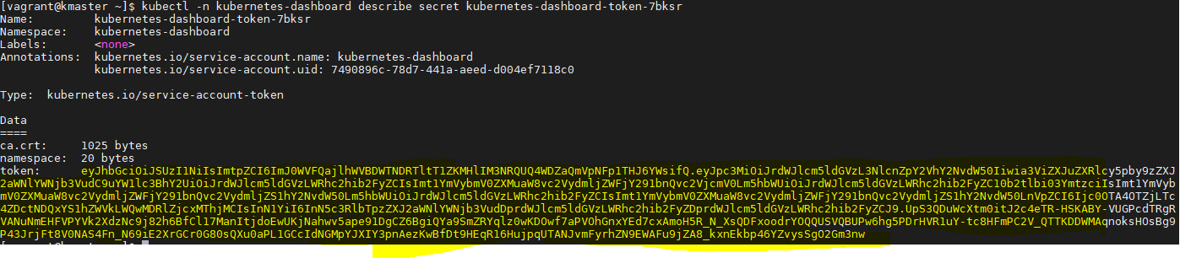

Now go to the web browser and access <https://masterip:32323>

It will prompt you for the token. Copy the token and paste it to browser and you will get successfully logged into the Kubernetes dashboard.

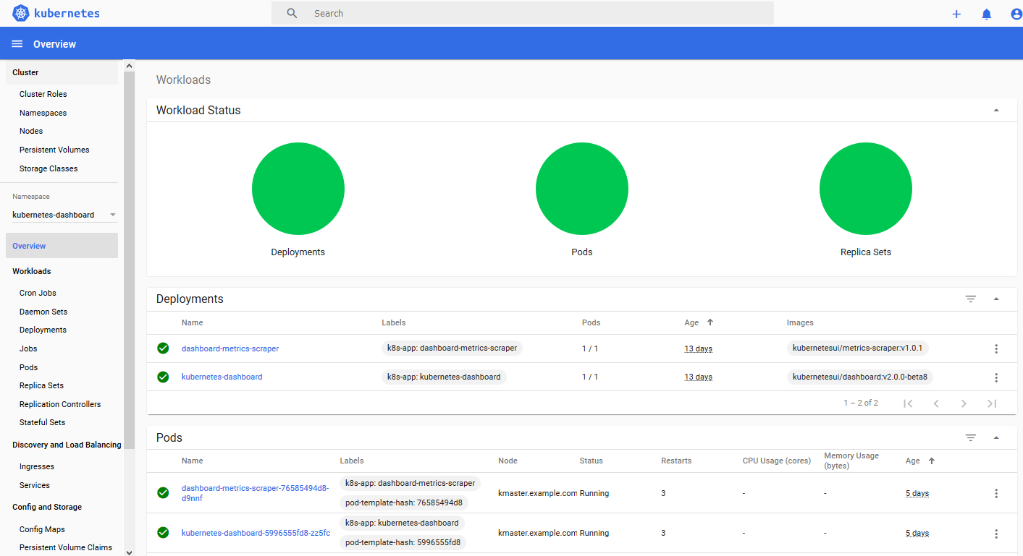

Now we are ready with the setup of kubernetes with one master node and two worker node and Kubernetes dashboard.

Now we will deploy a simple nginx application by executing below commands.

#kubectl run nginx --image nginx 

To check our nginx application has been deployed and running.

#kubectl get pods



To expose the port of nginx application to access it from outside the container cluster

#kubectl expose deployment nginx --type NodePort --port 80



To check the port no. on which nginx service has been running on. The highlighted port no. is used for access the application from outside.

#kubectl describe svc nginx

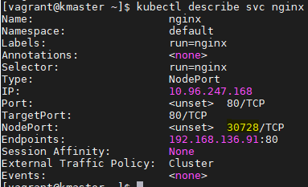

Now go to the browser and run <http://workerip:30728> . You will be landed on nginx default home page.

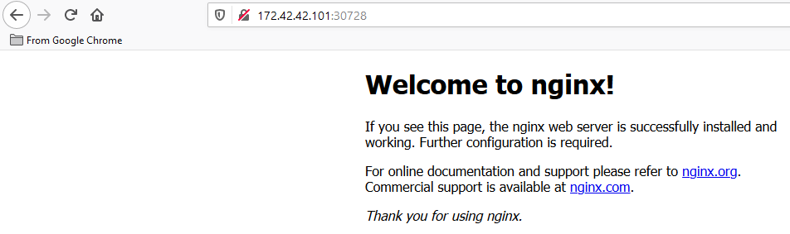

And we have successfully deployed our nginx web server….

****************Thanks********************